**Object Oriented Programming**

**Laboratory**

**Assignment – 4**

**Submitted By:**

Yishap Khanal

21052960

CSE-34 Date: 13th October,2022

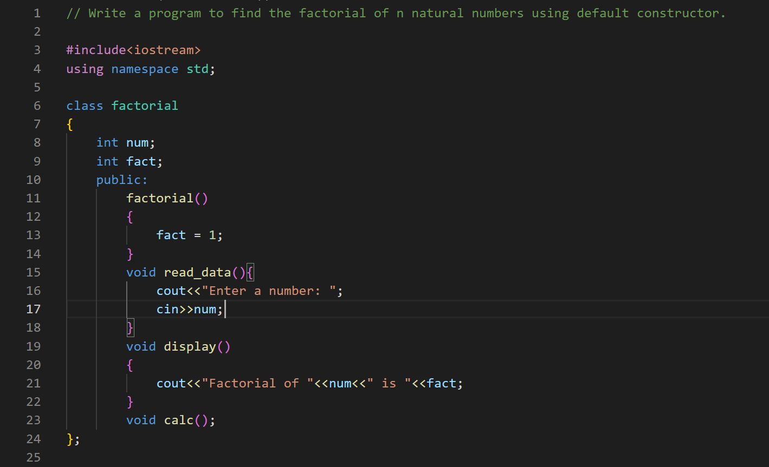**Question 1:**

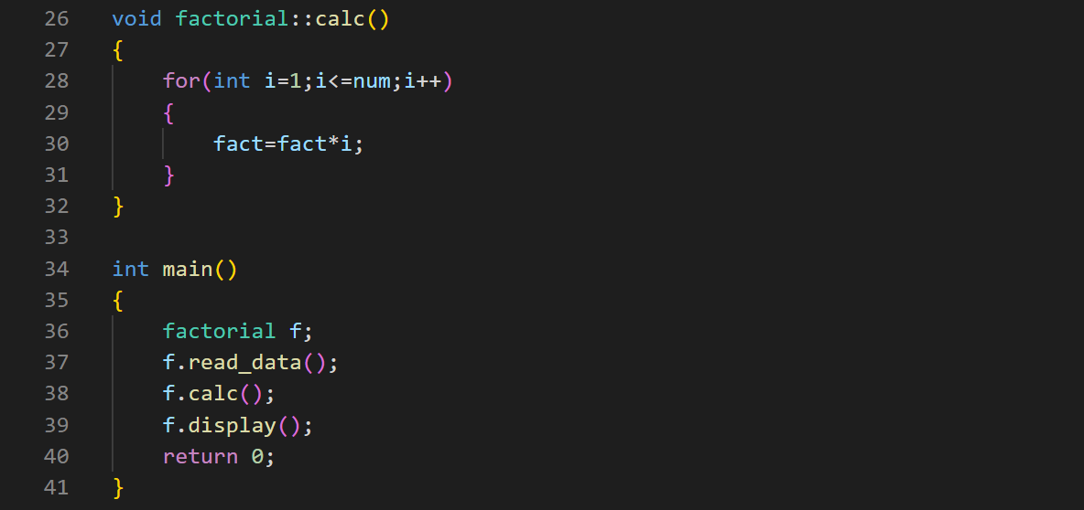

Output:

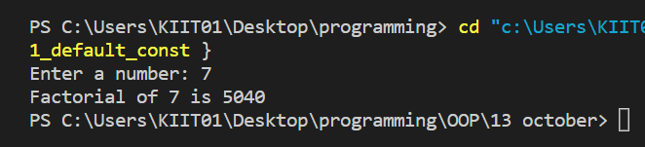

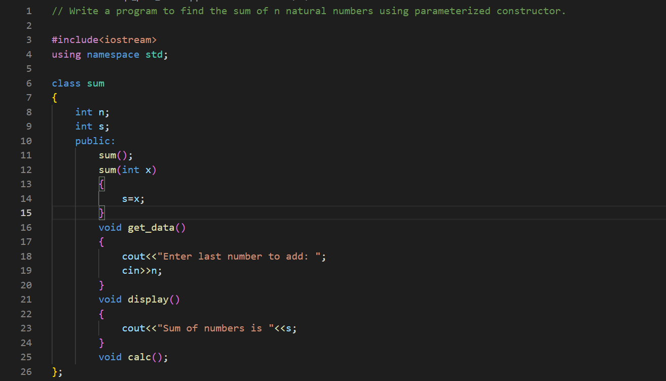**Question 2:**

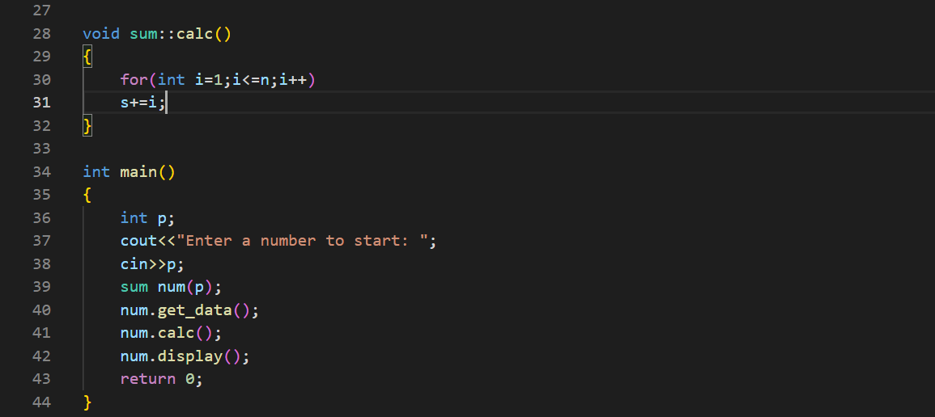

Output:

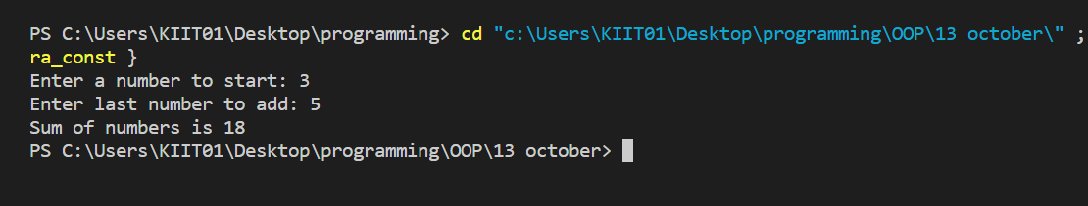

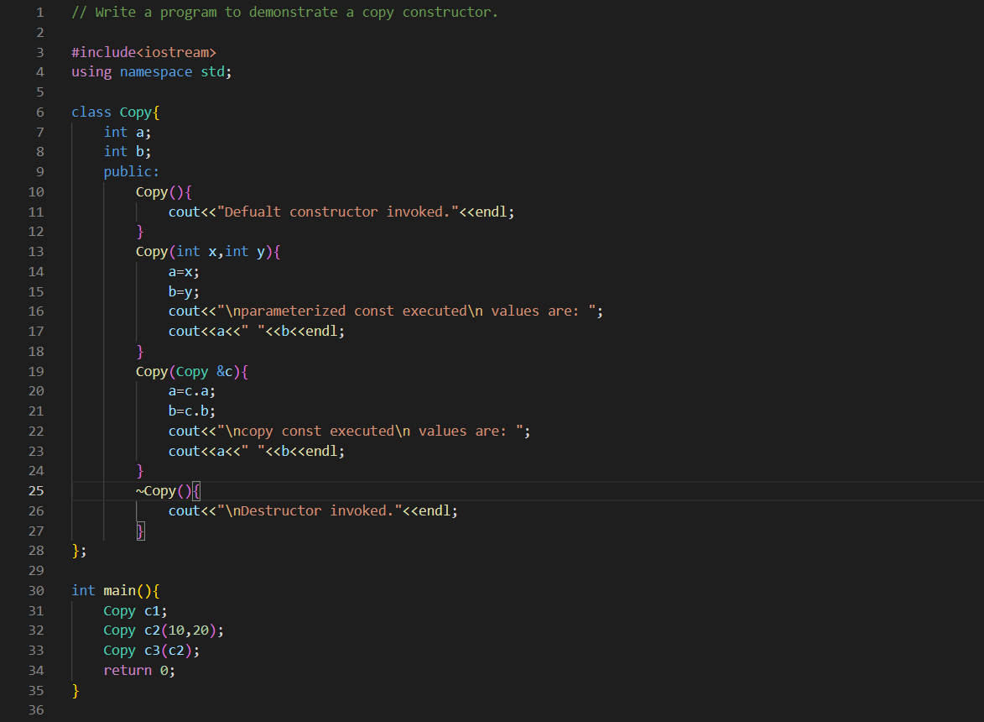**Question 3:**

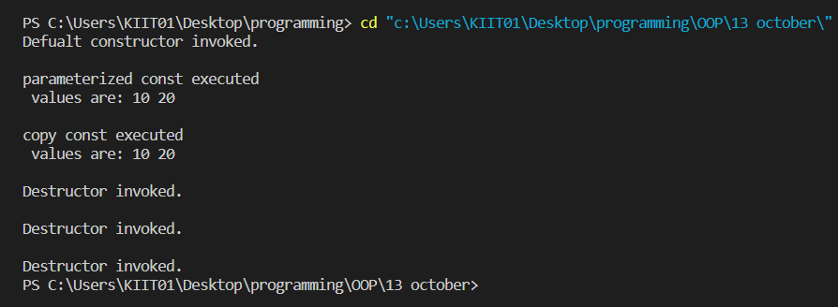Output:

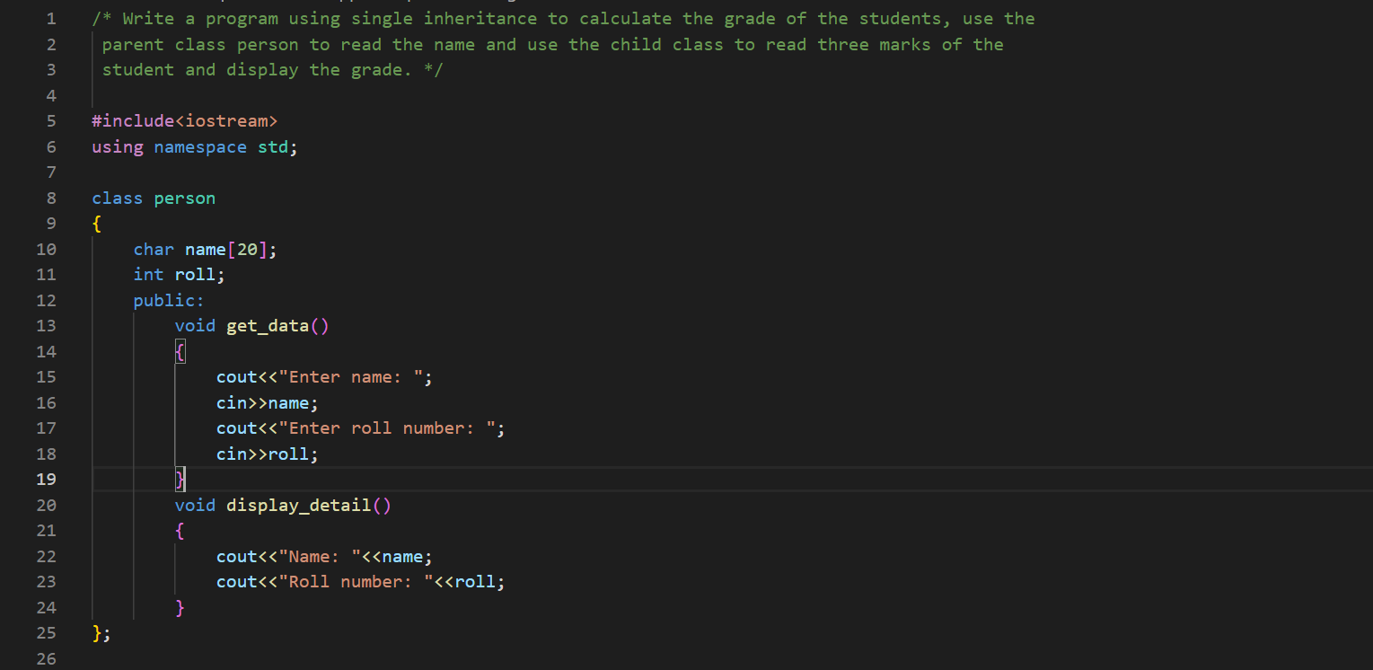**Question 4:**

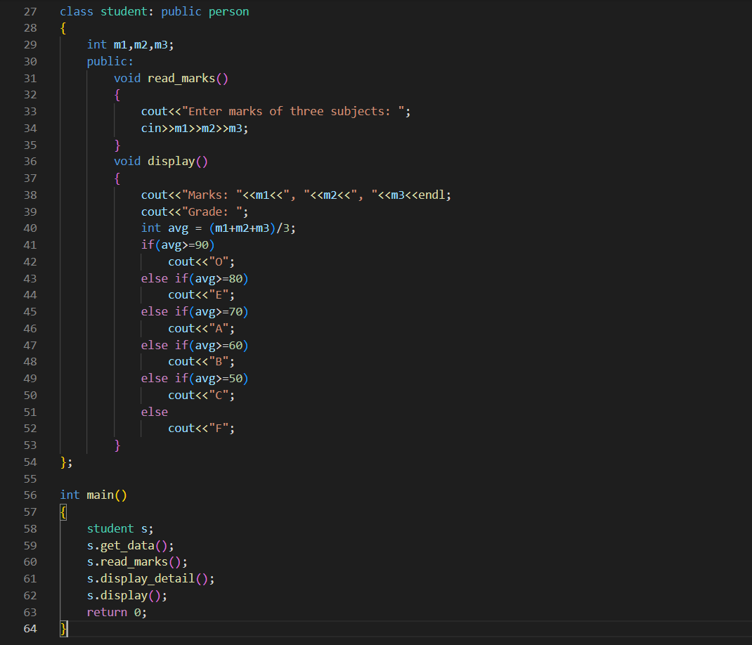

Output:

